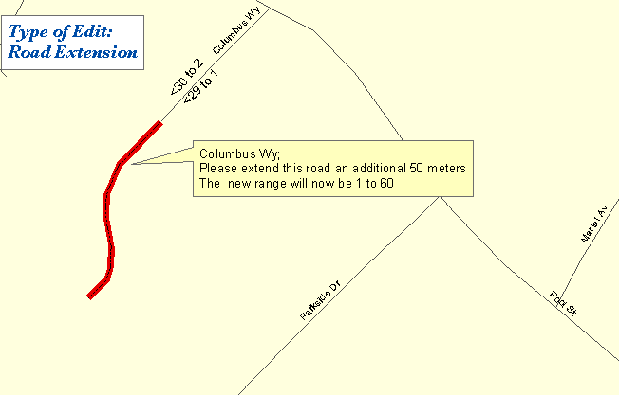

One Maine Enhanced 9-1-1 Update Form will need to be filled out for the above edit. The following sections are found on MSAG Update Forms and serves as an example as to what information needs to be provided to Emergency Services Communications Bureau/GIS in order to complete the edit. In addition, please provide all the information noted on the map above by marking it on a copy of the map book page. Please submit both the map book page and the Update Form to Emergency Services Communications Bureau/GIS.

FORM 1

- □ B. Street Extension: | Effective Date: 1/24/2003
1. Street Name: Columbus Wy
2. Begins at this address: 30
3. Addressing Interval: 50 ft | - 25ft. | - 50ft. | - Other
4. Approximate length, if available 50 meters

- □ E. Address Range Change | Effective Date: 1/24/2003
Street Name: Columbus Wy
Reverse direction of numbering | Reverse odds/evens
Number range change: ___Odds ___Evens _x__Both
Old range: low _1__ high_30__
New range: low _1__ high_60__

Remarks: Columbus Wy was extended because continued development along this road

